HELP MANUAL

RESOURCE ALLOCATION

Campus Together

DHIRUBHAI AMBANI INSTITUTE OF INFORMATION AND
COMMUNICATION TECHNOLOGY (DA-IICT)

GETTING STARTED

1.1 Resource Allocation Manual

3.2.2.2 Request a Resource

3.2.2.2.1 Apply for the Issue of a Lab Resource
Supported User Classes: Student, Faculty

Step 1: Click on ‘Resource’ tab on the navigation bar.

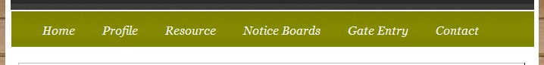

Step 2: Click on ‘Lab Resources’ on the Sub-Navigation Menu.

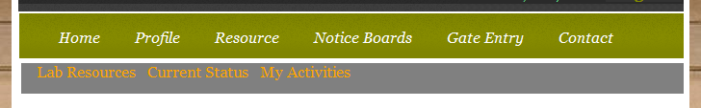

The List of all the available resources would appear.

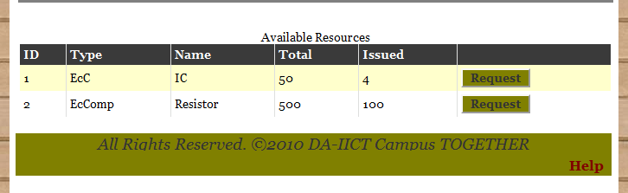

Step 3: Click on ‘Request’ Button at the end of each row in the table shown to request for the issue of that particular Resource.

A Request Form would appear on the Webpage.

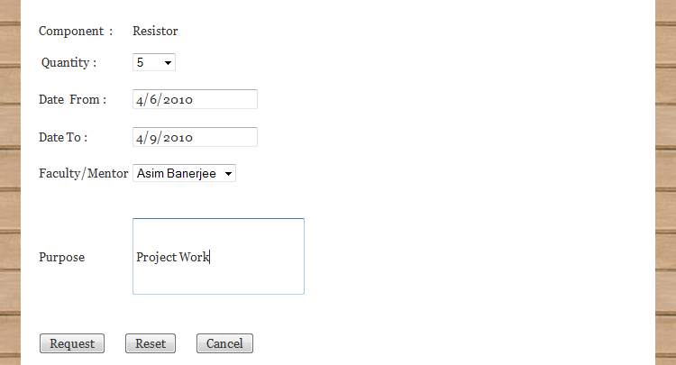

Step 4: Fill up the Above Form accordingly and
Click on ‘Request’ button for sending a request for the issue of the item.
Click on ‘Reset’ button to reset the filled form dat.
Click on ‘Cancel’ button to cancel the request.

A Notification would be generated for User information.

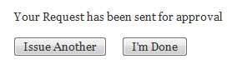
Step 5: Click on ‘I’m Done’ button to finish request for issue of a lab resource.
Click ‘Issue another’ button to request for other resource and follow all the steps
From 1 to 5.

3.2.2.2.2 Search for a Particular Resource by Name.
Supported User Classes: Student, Faculty

Step 1: Click on ‘Resource’ tab on the navigation bar.

Step 2: Click on ‘Lab Resources’ on the Sub-Navigation Menu.

The Following Search would appear on the page.

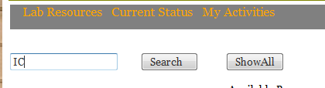

Step 3: Enter the name of the Resource and Click on ‘Search’ Button.

The Following information would appear based on your search word.

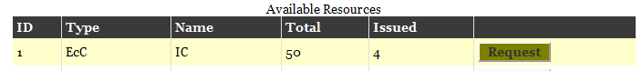

3.2.2.2.3 Status of Request

Step 1: Click on ‘Resource’ tab on the navigation bar.

Step 2: Click on ‘Current Status’ on the Sub-Navigation Menu.

All the Pending Status is tracked and a list of all requests would be available for the user.

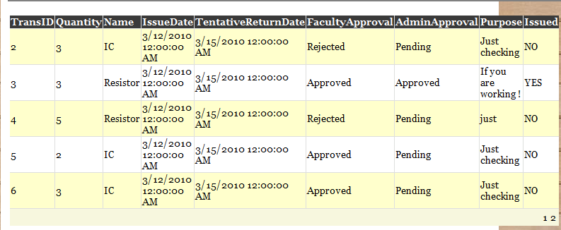

3.2.2.2.4 Viewing User Activity (Record of all Approved and issued Requests)

Step 1: Click on ‘Resource’ tab on the navigation bar.

Step 2: Click on ‘My Activities’ on the Sub-Navigation Menu.

(A Detailed view of all the Resource Requests would appear on the webpage.)

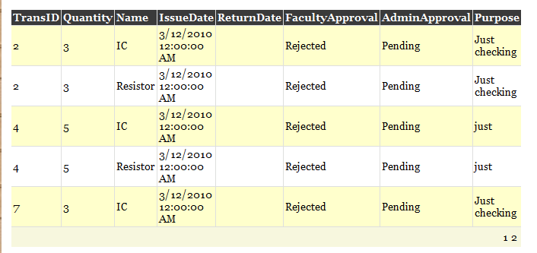
3.2.2.2.5 Apply for access into Lab/LT/CEP Room.
Supported User Classes: Faculty, Clubs/Committees

Step 1: Click on ‘Resource’ tab on the navigation bar.

Step 2: Click on ‘Rooms’ on the Sub-Navigation Menu.



(The Following page would be displayed.)

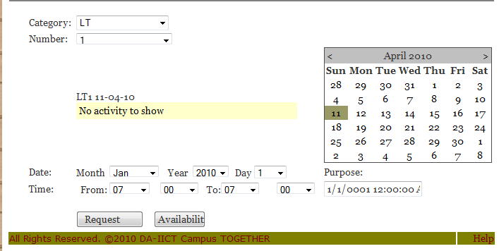

Step 2: Fill in the Details, as required in the form.
Click on ‘Availability’ Button to check for the availability of the Room.

Step 3: Click on ‘Request’ Button to request for the particular room.



3.2.2.2.6 Approve Student/Club/Committee Requests.
Supported User Classes: Faculty, Admin, Lab In charge, Lab Resource Allocator

Step 1: Click on ‘Resource’ tab on the navigation bar.

Step 2: Click on ‘Requests for Approval’ on the Sub-Navigation Menu.

(The Following page would be displayed.)
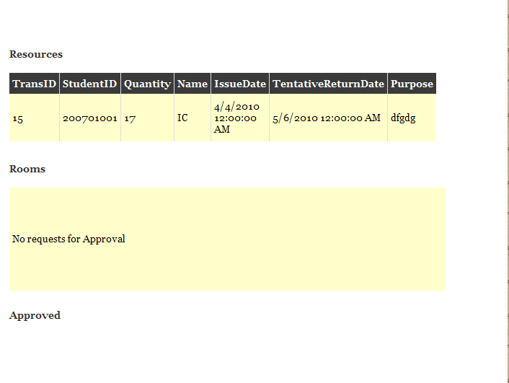

Step 3: Click on ‘Approve Request’ Button against each received requests to approve them.
3.2.2.2.7 Issue a Resource.
Supported User Classes: Lab Resource Allocator

Step 1: Click on ‘Resource’ tab on the navigation bar.

Step 2: Click on ‘Issue a Resource’ on the Sub-Navigation Menu.

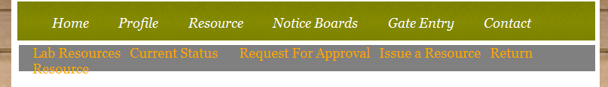

(The Following page would be displayed.)

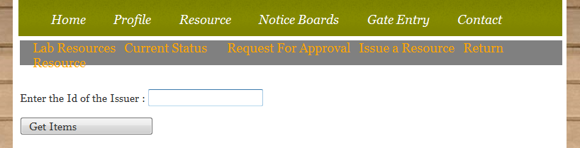

Step 3: Enter the User ID of the request Holder and Click on ‘Get Items’ button to get a list of items the user has requested for.

Step 4: Click on ‘Issue’ button against the request table displayed for issuing that particular item to the user.

3.2.2.2.8 Record Returning of an issued Resource.
Supported User Classes: Lab Resource Allocator

Step 1: Click on ‘Resource’ tab on the navigation bar.

Step 2: Click on ‘Return Resource’ on the Sub-Navigation Menu.

(The Following page would be displayed.)

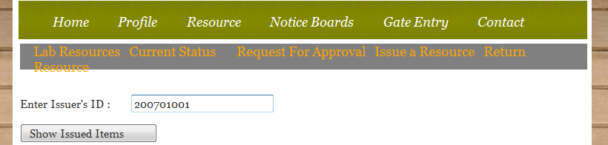

Step 3: Enter the User ID of the User and Click on ‘Show Issued Items’ button to get a list of items the user has been issued.

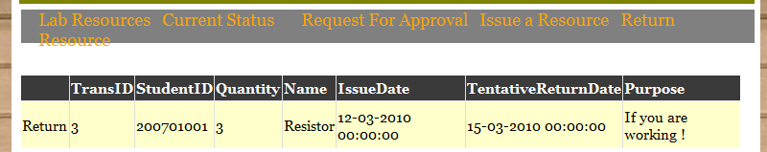

Step 4: Click on ‘Return’ button against the request table displayed above.
This finishes the process of returning a resource.

